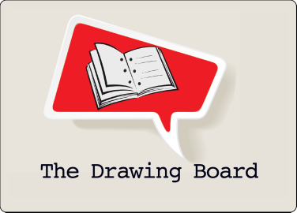

SCRIPT SUBMISSION FORM
For Table Reading Consideration

Name: _____________________________________________________________

Email: _____________________________________________________________

Submission Date: _______________________________________________________

Title of Project: _______________________________________________________

- What is your script about?

- Is this a first draft? If not, which draft are you submitting?

- What are you working on right now with this script?

- What is your goal for the table read?

- Has this script had a table read before? If yes, with which company?

- Writers are required to attend a Drawing Board reading before their script can be considered. Have you been to a reading at The Drawing Board before?
If not, see our reading schedule at www.thedrawingboardnyc.com

*********************************************************************************************
Please email this form to thedrawingboardnyc@gmail.com along with your script.
If you have not received feedback on your script within six months, please feel free to follow up with us.
Thank you for bringing your script to The Drawing Board!

